GL BAJAJ INSTITUTE OF TECHNOLOGY AND MANAGEMENT Academic Year 2025–26
Project Title: Campus Clone – Unified College Ecosystem
Web Application Based
Project Overview
The project "Campus Clone (MPIA)" is a web-based initiative developed for the students of GL Bajaj Institute of Technology & Management, Greater Noida. The system aims to solve the fragmentation of campus communication by providing a centralized, verified platform (restricted to official @glbitm.ac.in domains) that consolidates departmental announcements, student forums, club activities, and academic task management. By leveraging real-time communication and an AI-driven assistant, the application seeks to eliminate the chaos of unofficial messaging groups, enhance student engagement, and streamline the college experience into a single, cohesive digital ecosystem.
Objectives
The core objectives of this project are to design and develop a secure web application that acts as a central hub for college students; to provide a real-time, WebSocket-enabled chat interface for departmental and club communications; to integrate a context-aware AI campus assistant for instantly resolving student queries; to implement a sequential task pipeline (member-to-member handoff) for collaborative academic projects; and to offer a centralized event and media directory for better campus engagement.
Methodology
The development follows an Agile methodology with iterative feature sprints. The front-end is built for cross-platform responsiveness using modern UI principles (HTML5, CSS3, Tailwind styling, and Vanilla JS) with 3D elements powered by Three.js. The back-end employs a robust Node.js and Express server architecture to handle automated routing and logic. The system incorporates real-time WebSockets (Socket.io) for instant messaging, domain-restricted authentication for security, and RESTful APIs connecting to a database for data persistence. Additionally, a Large Language Model API is integrated to power the automated AI campus assistant.
Project Team
Role | Name | Roll Number
Project Leader | Atharva Vaish | 2501920110125
Backend | Bhoomika | 2501920110140
Frontend | Bhavya Kansal | 2501920110139
A P I | Ayush Soni | 2501920110135
Project Guide: Ms. Pooja Tomar
Project Category: Web Application Based Project
Project Area: Web Development & Real-time Systems



Prepared to: | Prepared by:
Mention fellow Canva users. Just @ them directly on the document. | @name
Address: | 123 Anywhere St., Any City
Contact: | +91-123-4567890
Website: | www.reallygreatsite.com

 | Table of Contents
The Team
Project Overview
Industry Analysis
Budget Plan

About Us

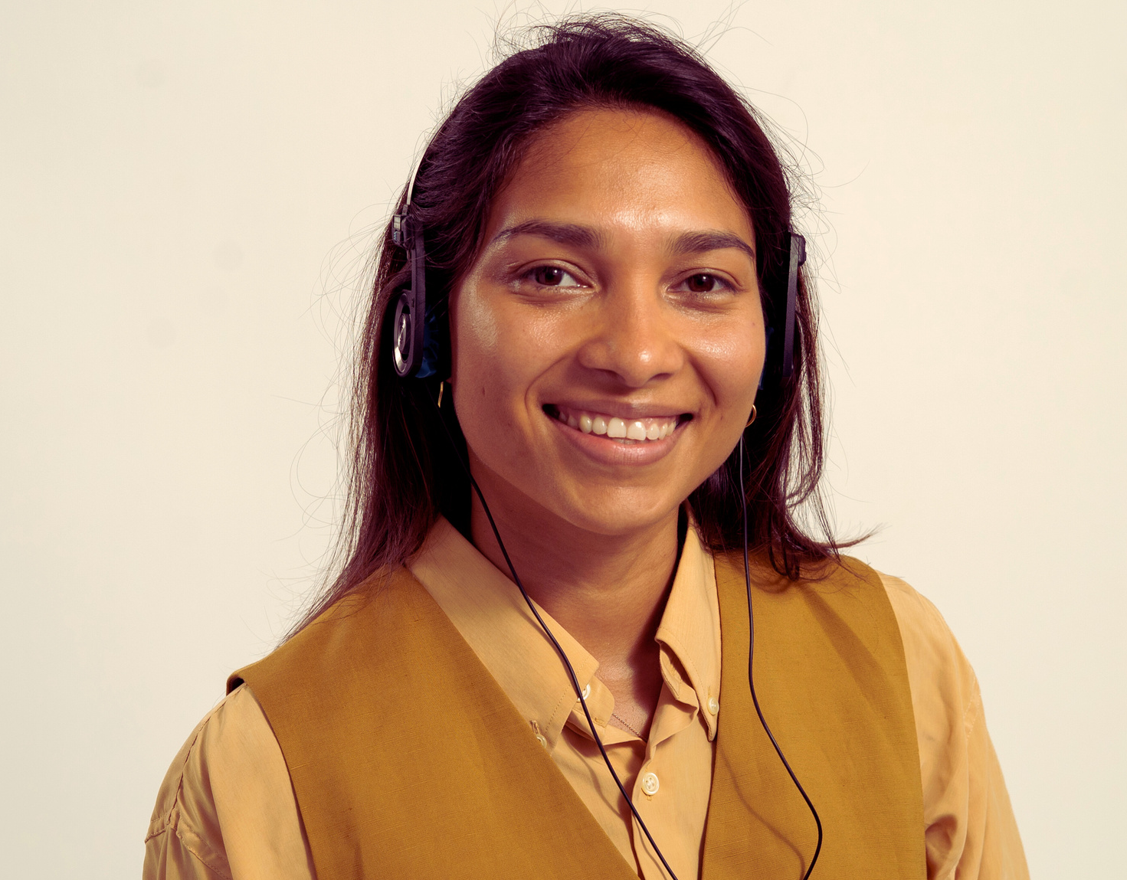 |  | 
@Name  Chief Executive Officer | @Name  Chief Financial Officer | @Name  Chief Operations Officer
Explain what they do for the business. How much experience do they have? What are their achievements? You may also add a fun fact about them. | Explain what they do for the business. How much experience do they have? What are their achievements? You may also add a fun fact about them. | Explain what they do for the business. How much experience do they have? What are their achievements? You may also add a fun fact about them.

Our Team

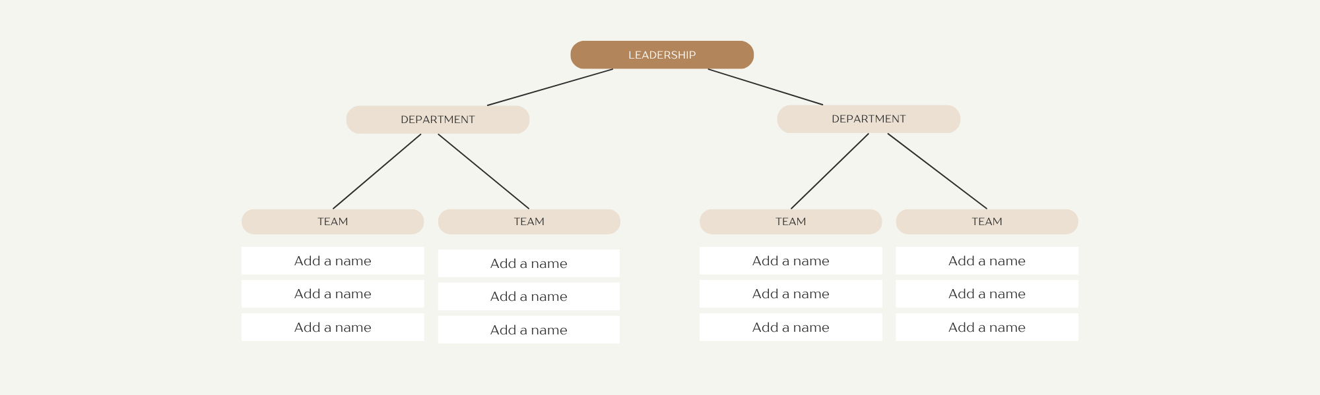
Map of the Organisation

Project Overview

Project proposals are outlines that describe the steps being taken to complete a project. They can be used in any industry as long as they contain all the important details. This includes the research behind the project, the basic idea and its relationship to the brand and what needs to be implemented to achieve the project. A good way to start your project proposal is by summarising your idea.
List the reasons behind it, the people involved, your involvement and how much the overall project will cost. Add your objectives and pay particular attention to the problems you’re trying to solve with your idea. Next, figure out how you’re going to accomplish your goals. Write down the steps you’re planning to take, the people you’ll be working with and the estimated time of completion.


Industry Analysis
Give a brief explanation for the page

Competitor Name
Duplicate the SWOT table as you evaluate other competitors.
Strength | - Add an entry  - Add an entry  - Add an entry
Weakness | - Add an entry  - Add an entry  - Add an entry
Opportunities | - Add an entry  - Add an entry  - Add an entry
Threats | - Add an entry  - Add an entry  - Add an entry
Write a header here | Write about the broader industry your business is in. Specify what industry it is - where it is, how big it is, what its general characteristics are and what the usual products and services are available.  Who are the usual players in the industry? Is there a major entity that dominates the market or not? Which companies would be your potential competitors based on the services they are offering?



Canva Tip
Edit this Scrollable Design and bring your content to life! To add more to your Doc, press / (forward slash) on your keyboard and select Scrollable Design.

Future Plans
Describe what the page is about

 | Write a header here  Map out your future plans for the business. Dream big! These plans could include expansion projects, new product offerings and major partnerships. Discuss how much impact you want to bring to the industry. This enables potential investors also to be optimistic about the business.
Add a big goal
Briefly elaborate on what you want to discuss.
Add a milestone
Briefly elaborate on what you want to discuss.
Add a big goal
Briefly elaborate on what you want to discuss.
Add a milestone
Briefly elaborate on what you want to discuss.

Contact us for
further inquiries




GL BAJAJ INSTITUTE OF TECHNOLOGY AND MANAGEMENT Academic Year 2026–27

Project Title: Campus Clone – Unified College Ecosystem
Web Application Based
Project Overview
The project "Campus Clone " is a web-based initiative developed for the students of GL Bajaj Institute of Technology & Management, Greater Noida. The system aims to solve the fragmentation of campus communication by providing a centralized, verified platform (restricted to official @glbitm.ac.in domains) that consolidates departmental announcements, student forums, club activities, and academic task management. By leveraging real-time communication and an AI-driven assistant, the application seeks to eliminate the chaos of unofficial messaging groups, enhance student engagement, and streamline the college experience into a single, cohesive digital ecosystem.
Objectives
The core objectives of this project are to design and develop a secure web application that acts as a central hub for college students; to provide a real-time, WebSocket-enabled chat interface for departmental and club communications; to integrate a context-aware AI campus assistant for instantly resolving student queries; to implement a sequential task pipeline (member-to-member handoff) for collaborative academic projects; and to offer a centralized event and media directory for better campus engagement.
Methodology
The development follows an Agile methodology with iterative feature sprints. The front-end is built for cross-platform responsiveness using modern UI principles (HTML5, CSS3, Tailwind styling, and Vanilla JS) with 3D elements powered by Three.js. The back-end employs a robust Node.js and Express server architecture to handle automated routing and logic. The system incorporates real-time WebSockets (Socket.io) for instant messaging, domain-restricted authentication for security, and RESTful APIs connecting to a database for data persistence. Additionally, a Large Language Model API is integrated to power the automated AI campus assistant.
Project Team
Role | Name | Roll Number
Project Leader | Atharva Vaish | 2501920110125
Backend | Bhoomika | 2501920110140
Frontend | Bhavya Kansal | 2501920110139
A P I | Ayush Soni | 2501920110135
Project Guide: Ms. Pooja Tomar
Project Category: Web Application Based Project
Project Area: Web Development & Real-time Systems

GL BAJAJ INSTITUTE OF TECHNOLOGY AND MANAGEMENT Academic Year 2025–26
Project Title: Campus Clone – Unified College Ecosystem
Web Application Based
Project Overview
The project "Campus Clone (MPIA)" is a web-based initiative developed for the students of GL Bajaj Institute of Technology & Management, Greater Noida. The system aims to solve the fragmentation of campus communication by providing a centralized, verified platform (restricted to official @glbitm.ac.in domains) that consolidates departmental announcements, student forums, club activities, and academic task management. By leveraging real-time communication and an AI-driven assistant, the application seeks to eliminate the chaos of unofficial messaging groups, enhance student engagement, and streamline the college experience into a single, cohesive digital ecosystem.
Objectives
The core objectives of this project are to design and develop a secure web application that acts as a central hub for college students; to provide a real-time, WebSocket-enabled chat interface for departmental and club communications; to integrate a context-aware AI campus assistant for instantly resolving student queries; to implement a sequential task pipeline (member-to-member handoff) for collaborative academic projects; and to offer a centralized event and media directory for better campus engagement.
Methodology
The development follows an Agile methodology with iterative feature sprints. The front-end is built for cross-platform responsiveness using modern UI principles (HTML5, CSS3, Tailwind styling, and Vanilla JS) with 3D elements powered by Three.js. The back-end employs a robust Node.js and Express server architecture to handle automated routing and logic. The system incorporates real-time WebSockets (Socket.io) for instant messaging, domain-restricted authentication for security, and RESTful APIs connecting to a database for data persistence. Additionally, a Large Language Model API is integrated to power the automated AI campus assistant.
Project Team
Role | Name | Roll Number
Project Leader | Atharva Vaish | 2501920110125
Backend | Bhoomika | 2501920110140
Frontend | Bhavya Kansal | 2501920110139
A P I | Ayush Soni | 2501920110135
Project Guide: Ms. Pooja Tomar
Project Category: Web Application Based Project
Project Area: Web Development & Real-time Systems

